STANDISH VOICE
SURVEY OF PARKING IN STANDISH
JANUARY 2016

Contents
1. Introduction 3
2. Methodology 3
3. Results 4
3.1 Existing parking 4
3.2 Calculated Parking Requirements 6
4. Discussion 9
5. Summary 10

Introduction
The Standish Voice Neighbourhood Plan consultation (Summer 2015) results highlighted that parking is an issue for many people in Standish. With the 1400+ new houses planned to be built in Standish in the near future, it is likely that this situation will only deteriorate.
In order to try to quantify the problem, Standish Voice has undertaken a study of existing available parking in the village, and a theoretical exercise to calculate how many parking spaces Standish should have. The findings from this work are presented in this report, though the report does not intend to offer any solutions to the perceived problem.

Methodology
The first exercise was to determine the area to consider as relevant. Web research indicates that ¼ mile (400m) is a reasonable walking distance from parking to shops/services (for able bodied people). This fits quite well with the layout of Standish as the vast majority of the shops and services in Standish fall within a ¼ mile radius of Standish crossroads. The area thus considered is shown in figure 1.
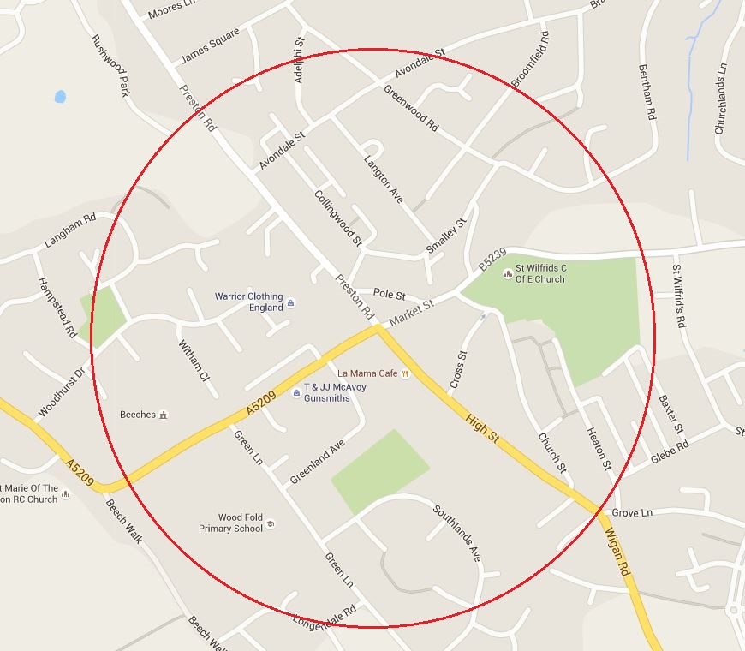
Figure 1. Map showing area considered for parking (1/4 mile radius of crossroads)

With the area identified, 2 members of Standish Voice (R. Wade and P. Ogden) physically surveyed all the available parking in this area on 19 December 2015, counting spaces and noting any restrictions on use i.e. time restriction or private ownership with signposted restrictions. The findings of this survey are tabulated later in this report.
The theoretical calculation of parking requirements is somewhat more long winded, the basic premise being that if Standish were to be built from scratch today, with the number and size of shops/services that we actually have, how many parking spaces would be required? As (anecdotally), parking is only an issue during the day, only premises in use during the day were included. Also, those premises with their own parking (therefore not necessarily requiring any public parking) were excluded. Formulae given in planning guidance were then used to calculate number of spaces depending on floor area and nature of premises (in planning terms, Use Class).
With this in mind, a physical survey of all relevant premises in the identified area was undertaken on 3 January 2016. A use class for each was then assigned, which though possibly incorrect, should have insignificant effect on subsequent calculations. As a rough check, the number of premises in each use class was compared with those in Wigan Borough Retail and Centres Evidence Paper October 2015 and found to be similar. This document also gives total floor area for each use class, so this was used as a basis to calculate an adjusted floor area based on survey results.

Results

3.1 Existing parking
Standish Parking Survey
Date: 19/12/2015
Description | Type | Spaces | Disabled | P&T
Summary | Public | 100 | 4 | 0
 | Private | 543 | 23 | 12
 | Total | 643 | 27 | 12
Description | Type | Spaces | Disabled | P&T | Restriction | Note
Pole St Car Park | Public | 12 | 0 | 0 | 2 Hours
Smalley St Car Park | Public | 20 | 0 | 0 | NR
The Globe Car Park | Public | 12 | 0 | 0 | NR | *3
Quakers Place Car Park | Public | 17 | 0 | 0 | NR
Smalley St Layby | Public | 6 | 0 | 0 | NR | *1
Market Place on Road | Public | 7 | 0 | 0 | NR | *1
Heaton St Car Park | Public | 14 | 0 | 0 | NR | *2
Cross St on Road | Public | 8 | 0 | 0 | 2 Hours
Pole St on Road | Public | 4 | 0 | 0 | 30 Mins
Pole St on Road | Public | 0 | 4 | 0 | NR
Standish Labour Club | Private | 20 | 0 | 0
Smalley St Businesses | Private | 10 | 0 | 0
Lloyds Bank | Private | 15 | 0 | 0
St Wilfs Church Hall | Private | 20 | 2 | 0
The Lychagate | Private | 4 | 0 | 0
Potter Bar / Vets | Private | 20 | 0 | 0
Community Centre | Private | 6 | 0 | 0
The Globe | Private | 2 | 1 | 0
Prosper Finanacial Advisors | Private | 3 | 0 | 0
Police Station | Private | 5 | 0 | 0
Chadwick Butchers | Private | 59 | 1 | 0
Village Hair | Private | 5 | 0 | 0
Health Centre | Private | 16 | 3 | 0
Methodist Church | Private | 10 | 0 | 0
LA Mamas | Private | 17 | 1 | 0
Neils Gym | Private | 7 | 0 | 0
Spar | Private | 22 | 0 | 0
Dog & Cartridge | Private | 8 | 0 | 0
The Beeches | Private | 75 | 3 | 0
W&L Hospice Shop | Private | 6 | 0 | 0
Library | Private | 6 | 1 | 1
Cross St Centre | Private | 17 | 0 | 0
Cheshire Chicks | Private | 5 | 0 | 0
The Coop | Private | 3 | 1 | 0
Aldi | Private | 91 | 6 | 9
Print Shop | Private | 5 | 0 | 0
Walsh Funeral | Private | 5 | 0 | 0
Parkes MoT Centre | Private | 10 | 0 | 0
Business Centre (opposite Lidl) | Private | 10 | 0 | 0
Lidl | Private | 50 | 4 | 2
Area surveyed within a quarter mile radius of the village centre (measured from the traffic lights)
Criteria:-
1. Private Car Parks where a business offers parking for the public whilst using the business
2. Public Car Parks open to all members of the public
3. Public On Road Parking only with designated, marked parking spaces with time restrictions
NR = No Restrictions
*1 - On road, not marked and not restricted so strictly speaking is outside of criteria
*2 - Just outside of area, so strictly speaking is outside of survey
*3 A private car park but with agreement that the public can use it until 6pm
Table 1. Existing Parking Provision

3.2 Calculated Parking Requirements
 |  |  |  | Use class | Day time use? | Own parking ?
1 | preston rd | lhs | aldi | A1 | y | y
2 |  |  | CK installations, double glazing etc | A1 | y
3 |  |  | standish print | A1 | y | y
4 |  |  | jos barbers | A1 | y
5 |  |  | dressing up | A1 | y
6 |  |  | tattoos | SG | y
7 | preston rd | rhs | winnard & brown est agent | A2 | y
8 |  |  | galloways | A1f | y
9 |  |  | hair co | A1 | y
10 |  |  | bet fred | A2 | y
11 |  |  | P&F solicitors | A2 | y
12 |  |  | pharmacy | A1 | y
13 |  |  | dry cleaners | A1 | y
14 |  |  | batt est agent | A2 | y
15 |  |  | card shop | A1 | y
16 |  |  | deli | A1f | y
17 |  |  | hair gallery | A1 | y
18 |  |  | jewellers | A1 | y
19 |  |  | vape shop | A1 | y
20 |  |  | bridal boutique | A1 | y
21 |  |  | bargain booze | A1 | y
22 |  |  | bumbles gifts | A1 | y
23 |  |  | coffee lounge | A3 | y
24 |  |  | nail place | A1 | y
25 |  |  | lidl | A1 | y | y
26 | high st | lhs | RBS | A2 | y
27 |  |  | rainbow | A1 | y
28 |  |  | global travel | A1 | y
29 |  |  | R&H est agent | A2 | y
30 |  |  | albion | A4
31 |  |  | balloon shop | A1 | y
32 |  |  | big white event co | A1 | y
33 |  |  | wild flowers | A1 | y
34 |  |  | posh frocks | A1 | y
35 |  |  | butty shop | A1f | y
36 |  |  | therapy centre | D1 | y
37 |  |  | mortgage clinic | A2 | y
38 |  |  | standish inks | A1 | y
39 |  |  | changing rooms | A1 | y
40 |  |  | hoot | A4
41 |  |  | got 2 go travel | A1 | y
42 |  |  | sugar shack sweets | A1 | y
43 |  |  | solicitors | A2 | y
44 |  |  | physio | D1 | y
45 |  |  | Barbers | A1 | y
46 |  |  | chemist | A1 | y
47 |  |  | H&H estate agent | A2 | y
48 |  |  | vets | SG | y | y
49 |  |  | castellis | A1 | y
50 |  |  | hairdressers | A1 | y | y
51 | high st | rhs | Spar | A1f | y | y
52 |  |  | subway | A1f | y | y
53 |  |  | A&P est agent | A2 | y | y
54 |  |  | yoga | D2 | y
55 |  |  | chic interior design | A1 | y
56 |  |  | mrs lyons | A3 | y
57 |  |  | la mama takeaway | A5
58 |  |  | taste of bengal | A3
59 |  |  | la mama | A3 | y
60 |  |  | taxi | SG | y | y
61 |  |  | in good taste | A3
62 |  |  | med practice | D1 | y
63 |  |  | chadwicks | A1f | y | y
64 |  |  | flooring | A1 | y | y
65 |  |  | last orders | A4
66 |  |  | B&L hair | A1 | y
67 |  |  | design & print | A1 | y
68 |  |  | prosper financial services | A2 | y | y
69 | school lane |  | McAvoys | A1 | y | y
70 |  |  | beeches | A3 |  | y
71 | market st |  | dermott barbers | A1 | y
72 |  |  | wuff n stuff | A1 | y
73 |  |  | price photography | A1 | y
74 |  |  | hairdressers | A1 | y
75 |  |  | charity shop | A1 | y
76 |  |  | dicinson accountants | A2 | y
77 |  |  | garlands | A1 | y
78 |  |  | dominos | A5
79 |  |  | chicken | A5
80 |  |  | solange sunbeds | SG | y
81 |  |  | kaz's kitchen | A1f | y
82 |  |  | autosave | A1 | y
83 |  |  | barbers | A1 | y
84 |  |  | bathrooms | A1 | y
85 |  |  | TSB | A2 | y | y
86 | pole st |  | COOP | A1 | y
87 |  |  | POST OFFICE | A1 | y
88 |  |  | Ladbrokes | A2 | y
89 |  |  | labour club | A4 |  | y
90 |  |  | tims pizza | A5
91 |  |  | standish tandoori | A5
92 |  |  | chippy | A5
93 |  |  | chippy | A5
94 | church st |  | standish energy solutions | B1 | y | y
95 |  |  | Csek24 security | B1 | y | y
96 |  |  | lychgate | A4
97 |  |  | potters | A4 |  | y
98 |  |  | oddfellows | D2
99 |  |  | community centre | D2 |  | y
100 |  |  | dentist | D1 | y
101 |  |  | framing | A1 | y
102 |  |  | globe | A4
103 | cross st |  | AFP investments | A2 | y
104 |  |  | hospice shop | A1 | y | y
105 |  |  | nails | A1 | y
106 |  |  | cross st gallery | A1 | y
107 |  |  | standish uniforms | A1 | y
108 |  |  | unity club | A4 |  | y
109 |  |  | magic tree shop | A1 | y
 |  |  | Use Class | No
 |  |  | A1f | 7
 |  |  | A1 | 53
 |  |  | A2 | 15
 |  |  | A3 | 6
 |  |  | A4 | 8
 |  |  | A5 | 7
 |  |  | B1 | 2
 |  |  | C3 | 8
 |  |  | D1 | 4
 |  |  | D2 | 3
 |  |  | SG | 4
Table 2. List of Premises, Use Class, and Whether in Daytime Use With Own Parking

 |  | From survey |  | From table 4*
Use class | Description | # off total | # in day time use without own parking | # off total, 2015 figure | m² | m² total in day time use, without own parking, after adjustments and scaling | standard car parking provision [per sq m or dwelling] | calculated # spaces req'd for day time use | suggested # spaces with local knowledge | disabled car parking provision
A1f | Shop- food retail | 7 | 4 | 5 | 4695 | 166 | 0.04 | 7 | 6
A1 | Shop- non food retail | 53 | 46 | 38 |  | 2886 | 0.03 | 96 | 80
A2 | Financial & prof services | 15 | 12 | 13 | 933 | 861 | 0.04 | 34 | 30
A3 | Food & drink (rest't) | 6 | 3 | 5 | 494 | 296 | 0.14 | 42 | 30
A4 | Pubs and bars | 8 | 0 | 2 | 254 | 0 |  | 0
A5 | Hot food takeaways | 7 | 0 | 10 | 853 | 0 |  | 0
B1 | Business- stand alone office | 2 | 0 | 0 | 0 |  | 0.03 | 0
C3 | Dwelling house | 8 | 8 | 8 | 282 | 282 | 1 | 8 | 8
D1 | Non-residential institution (Clinic, dentist) | 4 | 4 | 3 | 149 | 199 |  | 0 | 50
D2 | Ass'y/leisure (indoor sport) | 3 | 1 | 3 | 859 | 286 | 0.04 | 11 | 11
SG | not fitting any other use class | 4 | 2 | 3 | 899 | 599 | 0.04 | 24 | 5
 |  |  |  |  |  |  |  | 223 | 220 | 13
* | table 4 in Wigan Borough Retail and Centres Evidence Paper (October 2015)
Table 3. Calculation of Parking Requirements by Use Class

Discussion
100 spaces were found to be available for public use from the survey. This is likely to be quite an accurate figure as it relies on a straightforward count. In addition to this is some on-street parking, though many of the houses in the survey area, particularly those closest to the village centre, do not have their own off-street parking.
There is no perfect way to calculate parking requirements from scratch. The methodology used is commonly applied to planning applications for new developments though. The spaces per square meter factors applied do not currently have any enforceable powers, but they are listed in the Wigan Council Draft Allocations Plan so they are clearly good guidance, and similar figures are used all over the country by Councils. Wigan Council do not currently appear to have parking guidelines for health centres and dentists, so national guidance was used. The calculated parking requirement is not an absolute figure as assumptions are used, and traditional planning measures such as time restricted parking may be expected to make some improvements, but the calculation does imply such a significant shortfall that the parking situation can only improve by additional spaces being made available.
To give an idea of scale, to meet the calculated shortfall would require a single car park somewhat larger than the existing ALDI car park.

Summary
Standish currently has around 100 parking spaces and 4 disabled spaces available for public use.
Using calculations typically used for planning purposes, and local knowledge, Standish requires around 220 parking spaces and 13 disabled spaces.
From the above, Standish currently has a shortfall of 120 parking spaces and 9 disabled spaces.

Brian Jones
Standish Voice
January 2016

