Decision day close for School Lane widening plans
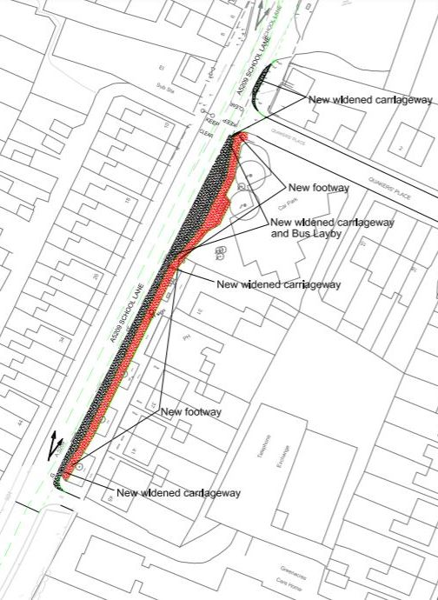
We are expecting Wigan Council’s Cabinet to discuss the proposal to widen School Lane in Standish next month.
The council’s ruling Cabinet committee is set to take the decision on whether or not to spend around £1.6m on a third lane – which Standish Voice, our councillors and the overwhelming majority of people in the village have objected to.
Council officers will produce a report and recommendation on the proposed scheme, which would widen the road from Green Lane down to Quakers Place. The council consulted residents on the plan last year and faced a barrage of opposition.
We hope the council upholds democracy and the consultation findings in good faith and scraps the proposal. We believe this scheme would be a waste of money which could be better spent elsewhere in Standish as it would attract more through traffic into the village, impact road safety, heighten pollution and allow the opening up more of our green fields to development. It would also destroy the character of one of the main routes into Standish.
The council will announce a number of other smaller projects soon, also paid for by ‘106 Section’ funding, money from housing developers which must be spent on infrastructure. Some has already been spent, including on Standish Leisure Centre and the upgrade of The Line. Other money is earmarked for extending Standish primary schools and smaller projects, including improvements to parks and walking and cycling routes.
We will keep you informed.

Boundary changes will reduce size of Standish-with-Langtree ward
The final recommendations on new boundaries for council wards in Standish have been published, with proposals to slightly reduce the size of Standish-with-Langtree ward.
But the controversial proposal to add the Boar’s Head area into Wigan Central ward has been dropped after objections from residents, councillors and Standish Voice.
Part of the Chorley Road area will move to Standish-with-Langtree ward from Aspull ward and all Old Pepper Lane and part of Pepper Lane will switch to Shevington ward.
The change shapes which areas are covered by Wigan councillors, but Standish Neighbourhood Area, which relates to Standish Voice as a Neighbourhood Forum, stays the same.
Parliament now needs to agree to the changes and they will apply to the 2023 council elections if the proposals are agreed.
You can see the final recommendations here: https://consultation.lgbce.org.uk/node/28212
The map shows the final recommendations for Standish and Shevington.

My Life Jubilee celebrations and the return of Standish Carnival
My Life charity in Standish is holding a four-day celebration of the Queen’s Platinum Jubilee, including the revival of Standish Carnival.
There will be lots to do for the whole family at their base on Pepper Lane over the long Bank Holiday Weekend of June 2nd to 5th.
The entertainment includes:
- Traditional beacon lighting, fireworks, bonfire and funfair
- Relaunch of the Standish Carnival
- Food and Beer Festival
- Spice Girls, Madness and Beatles tribute bands
- Live soul and Motown acts
- Artisan stalls
- Day at the Races
- Vintage car show
- Entertainment and fun activities for the whole family
The carnival will parade from Bradley Hall to Pepper Lane on Friday, June 3rd.
To find out more and to buy tickets, see: https://www.my-life.org.uk/the-queens-platinum-jubilee-celebration-for-wigan-and-standish-2022/?fbclid=IwAR3dLuvZsXazP8EOgORu5DIUdCg4YLotknhqChe5u7MqDeUNQwHcnDIne98

Facebook landmark
Standish Voice now has 11,000 followers on Facebook – thank-you to everyone who reads and comments on our posts.
We have rules to keep the page safe for everyone who uses it. You can see our rules on our website here: http://www.standishvoice.co.uk/us/
To date, only 8 people have been banned from commenting on this page for flagrantly breaching those rules – which is an incredibly low amount. Thank-you to everyone for keeping to them.
If you are a Standish Voice member, please Like our Facebook page as you will see our posts more often.

Council refuses to go back on Lurdin Lane planning permission
Wigan Council has said it will not rescind the planning permission on land at Lurdin Lane, off Chorley Road, despite the proposals still not being progressed after almost 10 years.
Standish Voice has asked the council to throw out the outline permission for the site as it is unfair on nearby residents to be left in limbo for so long over what will happen to the land.
After objections by residents, led by Standish Voice, the council decided not to sell land on Chorley Road which would give access to the housing development on greenfield land.
We then asked the local authority to rescind outline planning permission of around 100 homes, which was passed by a government inspector in 2015 after the council refused it. The follow-up detailed planning permission, needed to begin the work, was submitted in 2016 but has still not been determined.
The council says it is working with the developer, Bellway, on new ‘reserved matters’ plans.

Complaints over Rectory Lane development
Standish Voice has raised concerns about heavy plant and machinery being driven through the narrow roads of a housing estate to a new development site.
Lorries have been seen mounting pavements to get round cars on the Barrowcroft estate, off Chorley Road.
The new development has a totally inadequate Construction Environmental Management Plan, which regulates how developer Wainhomes carries out its building activities – not even having the name of the development inserted (see photo).
The council is now looking into the complaints, which have been echoed by residents and councillors.

